Australian Training Awards 2020

Queensland Finalist Profiles

Apprentice of the Year Award

Braden Hellmuth

Trainee of the Year Award

Breanna Cassidy

Australian School-based Apprentice of the Year Award

Jennifer Myers

Vocational Student of the Year Award

Ngaire Trigg

Aboriginal & Torres Strait Islander Student of the Year Award

Jabin Giblett

VET Teacher/Trainer of the Year Award

Michelle Clements

Small Employer of the Year Award

Kent Saddlery

Medium Employer of the Year Award

selectability Ltd

Large Employer of the Year Award

Hastings Deering (Australia) Ltd

Australian Apprenticeships Employer Award

Affinity Education Group

Industry Collaboration Award

TAFE Queensland and Rheinmetall Defence Australia Collaboration

School Pathways to VET Award

Sunshine Coast Technical Trade Training Centre (Caloundra State High School)

Apprentice of the Year Award

Braden Hellmuth

2020 – Finalist Queensland
Certificate III in Engineering – Mechanical Trade
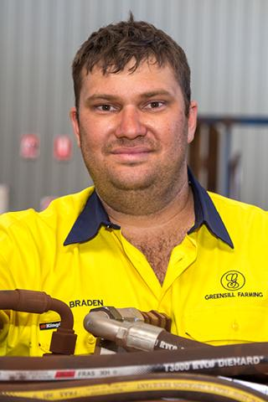
Braden Hellmuth developed an interest in agriculture as a 14-year-old picking fruit during his school holidays. He was encouraged to attend university where he completed a science degree. After graduating in 2013, he was drawn back to working on the land.
Braden had a limited knowledge of anything mechanical and even less on hydraulics or maintaining machinery. To further improve his learning, he enrolled in a Certificate III in Engineering – Mechanical Trade.
With new technology and automation entering the agricultural industry, Braden plans to undertake further studies. He has gained qualifications in data cabling, a range of licences relevant to the industry, hydraulics competencies and is currently doing a Certificate II in Automotive Air Conditioning Technology, further expanding his skills.
Braden regularly travels to Europe and America to attend trade shows and to evaluate and purchase new specialised equipment for his employer.

Trainee of the Year Award

Breanna Cassidy

2020 – Finalist Queensland
Certificate III in Business
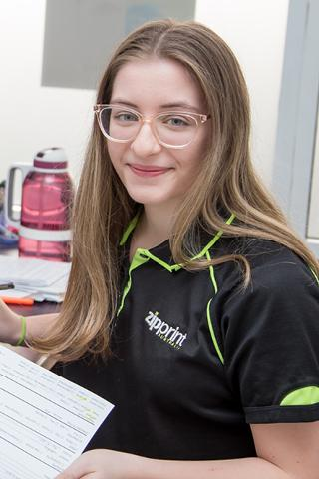
With an interest in graphic design and business, Breanna Cassidy realised a traineeship could kick-start her career and she started working at Zip Print Australia and enrolled in a Certificate III in Business.
Breanna feels especially proud that she completed a nationally recognised qualification because she did not achieve a high school certificate.
As she completed each competency, Breanna’s self-confidence and ability grew. She is a valued team member and can solve complex problems in a fast-paced and demanding workplace.
Breanna’s study achievements have been recognised by her RTO and during her training she was nominated for Student of the Month in recognition of her true passion for her traineeship.
This positive recognition is huge for Breanna and she has been inspired to take the next big leap in her career and plans on doing a course in graphic design.
She is continuing her learning journey with Zip Print and has commenced an apprenticeship in graphic pre-press.

Australian School-based Apprentice of the Year Award

Jennifer Myers
2020 -Finalist Queensland
Certificate III in Allied Health Assistance

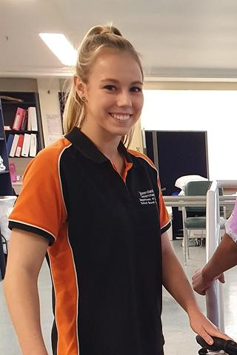
Jennifer Myers is a School-based Trainee at the Redcliffe Hospital as an Allied Health Assistant, working toward a Certificate III while she finishes Grade 12 at North Lakes State College.
A vocational education and training pathway appealed to Jennifer because she wanted to further explore what was involved in a career in allied health, focusing towards occupational therapy.
When she finishes her traineeship, Jennifer will have gained skills in five sectors of allied health, including medical imaging, dietetics, speech pathology, occupational therapy and physiotherapy.
Jennifer is confident she has made the right choice for her future career pathway as she will be able to start university one step ahead of her peers, thanks to her qualification and past two years of work experience.
She also encourages her friends and younger brother to pursue a VET qualification, telling them it’s the best pathway to set them up with practical experience and understanding before they move into their future career.

Vocational Student of the Year Award

Ngaire Trigg
2020 – Finalist Queensland
Diploma of Community Services

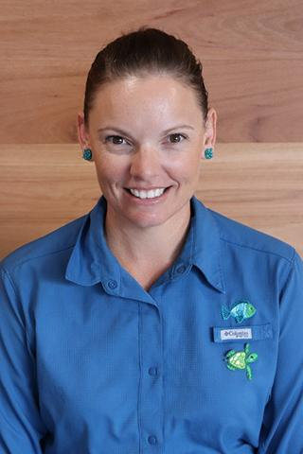
Studying for a Diploma of Community Development through TAFE Queensland North has been a game-changer for Ngaire Trigg.
Having previously worked in an office environment, Ngaire was certain that after time out of the workforce to raise her two girls, she wanted a change.
She switched her focus to tap into her passions for networking and supporting the natural environment.
When Ngaire signed up to do a diploma she never imagined that just 18 months later she would be close to finishing her qualification. Ngaire is now working in her dream job as an Environmental Support Officer with St Benedict’s Catholic School in Townsville.
Ngaire collaborates with teachers, other school staff and community leaders to develop activities that support students’ understanding of the outdoors, such as creating a native plant and bush tucker trail with support from local Aboriginal elders.

Aboriginal & Torres Strait Islander Student of the Year Award

Jabin Giblett
2020 – Finalist Queensland
Certificate III in Barbering
Jabin Giblett is a proud Aboriginal South Sea Islander who grew up in Mackay where he participated in Aboriginal dancing and performing for cultural events and schools.
Jabin had an interest in barbering and was cutting hair for friends and family. He applied for several apprenticeships without success. He found each employer he approached was seeking someone with experience.
In 2017, Jabin saw an ad for a new shop opening and they were looking for an apprentice barber. He was thrilled when he got the job, making him the first apprentice to be hired with The Hairport.
Jabin is now a qualified barber and works with disadvantaged youth. Having been incarcerated himself, his interest now lies in sharing with other young people how barbering changed his path and his life.
Suicide prevention is also important to Jabin, as he advocates for training to give barbers the skills to have conversations with clients, look for warning signs and recommend the right service providers to help.
When Jabin graduated from TAFE in February 2020, he received the TAFE Queensland RE Wearne Memorial Award for Excellence in Vocational Education.

VET Teacher/Trainer of the Year Award

Michelle Clements
2020 – Finalist Queensland

Michelle Clements is a dedicated AustCare trainer who began her career as a graphic artist before transitioning to her rewarding career in healthcare.
Michelle was inspired by her father who experienced early onset Alzheimer’s Disease and she wanted to extend her love and care to vulnerable people.
Michelle also completed a year of Registered Nursing training at University of Southern Queensland, gaining a Royal College of Nursing Australia Scholarship, which was deferred due to her father’s ill health. But this didn’t stop Michelle from achieving her dreams.
She found her true calling teaching with AustCare Training and takes great pride in being able to inspire people to care for others with empathy. Her passion lies in providing people with dementia the best opportunities to remain connected to community and live a good life. She’s been working with the organisation for five years, training students in Aged Care, Dementia Care, Home and Community, Disabilities, First Aid/CPR, Medications and Palliative Care.
Michelle prides herself on helping all students to succeed, reach their goals and gain employment.

Small Employer of the Year Award

Kent Saddlery
2020 – Finalist Queensland
Kent Saddlery was established in 1988 by Lyle and Helen Kent.
The company started with Lyle making every saddle. Now it is a larger operation that employs 14 staff and specialises in producing quality leather products.
In 2019, Kent Saddlery succeeded in its quest to have the Queensland Government reinstate leather production as a Queensland Apprenticeship. This gave saddlers around Queensland the ability to train and employ apprentices. At a time when apprentice training in the saddlery industry was non-existent in Queensland, it led to future growth and training of the sector.
Over the past 12 months, 70 per cent of the staff at Kent Saddlery participated in nationally accredited training. Out of the 10 apprentices employed, seven are first-year apprentices, and three are third-year apprentices. In addition, Kent Saddlery has been able to provide a new school-based apprentice the opportunity to start working toward his saddlery trade.

Medium Employer of the Year Award

selectability Ltd
2020 – Finalist Queensland
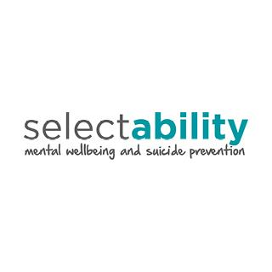
The organisation selectability Ltd is a not-for-profit organisation with over 320 staff, including psychologists, mental health nurses, counsellors, social workers, support coordinators lifestyle support workers, peer support workers, domestic cleaners, trainers, and life coaches. They also have more than 45 Australian Health Practitioner Regulation Agency registered mental health professionals.
All employees share the goal of improving the mental wellbeing of people in regional Queensland and supporting the prevention of suicide.
To ensure their services are meeting better practice standards, selectability Ltd ensures all employees take part in ongoing training.
When new employees begin at selectability Ltd, they undertake compulsory training. This is delivered through an internal online Learning Management System (LMS) that was developed in December 2018.
To ensure its Aboriginal and Torres Strait Islander clients are best serviced, selectability Ltd invested in its own Cultural Competency Training Program. The module in the LMS system is compulsory and employees must complete the unit before they start working for the organisation.
Ongoing staff engagement and employee feedback ensures training needs are identified and implemented without delay.

Large Employer of the Year Award

Hastings Deering (Australia) Ltd
2020 – Finalist Queensland

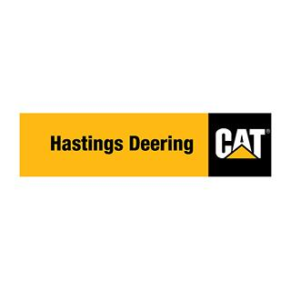
With a worldwide pandemic occurring in 2020, Hastings Deering leveraged the strength of its training culture to minimise the impact on staff.
In 2020, Hastings Deering employed 75 first-year apprentices, which is one of the largest intakes in the country. Apprentice diesel fitters, auto electricians and fabricators make up five per cent of their total workforce. Many of the apprentices are female, Indigenous or mature age and in 2020, 96 per cent of final year apprentices were offered ongoing roles.
The company provides unique training opportunities including work experience for school students and School-based Apprenticeships. They also provide traineeships in warehousing, laboratory operations and administration. Hastings Deering offers a graduate program in finance, business, IT, human resources and engineering.
With learning centres in Brisbane, Port Moresby and Christchurch, Hastings Deering remains one of Australia’s largest employers/trainers of apprentice diesel fitters.

Australian Apprenticeships - Employer Award

Affinity Education Group
2020 – Finalist Queensland

Affinity Education Group (AEG) is one of Australia’s largest private providers of early childhood education, owning and operating 166 Lifelong Learning Centres.
The group’s teachers, educators and assistants strive to help every child in their care reach their full potential. All educators hold, or are working towards, early childhood qualifications.
To facilitate this learning, AEG launched the Affinity Learning Academy (ALA) in 2017 to deliver professional development and early learning qualifications such as Certificate II in Early Childhood, Certificate III in Early Childhood and a Diploma of Early Childhood for its 3000-plus educators. Training incorporates online learning, industry expert training, workplace learning and on-the-job coaching and assessment.
In June 2020, the AEG and their subsidiary ALA formed a partnership with Industry Graduates, a specialist early childhood education and care learning and development consultancy. They identify longstanding casual employees working regular shifts and develop and train them to become a more permanent part of their workforce.

Industry Collaboration Award

TAFE Queensland and Rheinmetall Defence Australia Collaboration
2020 – Finalist Queensland

Rheinmetall Defence Australia is one of the leading providers of high-tech protection assets for soldiers on deployment. In 2019, Rheinmetall Defence Australia was awarded a contract to build 211 Combat Reconnaissance Vehicles in South East Queensland.
TAFE Queensland is the largest and most experienced provider of vocational education and training in Queensland.
A partnership between the two created a pathway to raise the skill level of experienced Australian welders to the better practice standard (ISO 9606). Australia has had a lack of qualified welders which meant to fulfil contractual obligations, companies and supply chains would be required to bring in overseas workers. This strategy would not align with the Australian Defence Force commitment to maximise local Australian industry involvement.
The collaboration has created the Fusion Welding Program, which delivers high-level training to the local workers building the new combat vehicles.
TAFE Queensland has developed the capability of its staff to deliver more than 20 short courses to more than 100 welders.
The scope and scale of current defence projects support long-term skilled jobs in this industry. However, by raising the capability of local workers and businesses, the opportunity to compete for further work on the international market has increased.

School Pathways to VET Award

Sunshine Coast Technical Trade Training Centre (Caloundra State High School)
2020 -Finalist Queensland

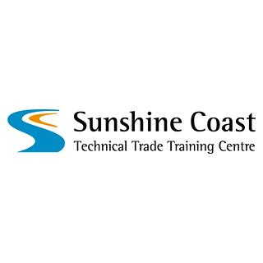
The Sunshine Coast Technical Trade Training Centre (SCTTTC) began in 2011 through a partnership between four state schools - Beerwah, Caloundra, Kawana Waters and Meridan.
The leaders of the schools recognised there was demand for future tradespeople on the Sunshine Coast to meet industry needs.
More than 400 local employers have hosted SCTTTC students for structured workplace learning, resulting in solid employment outcomes for young graduates.
The focus of the training program is to prepare students for industry. Trainers act as supervisors and mentors, having employed apprentices themselves, while the centre itself is treated as a workplace. All staff at the centre model behaviours expected in industry, mentoring and coaching students on business skills needed to succeed.
In its first year, SCTTTC had 30 students enrolled in four partner schools. Its reputation has grown immensely and in 2020 there were 226 students enrolled from schools across the Sunshine Coast.

